Introduction

The greatest asset any Institution can have is the Alumni system. Alumni are the people who represent the Institution in the real world. Alumni website is created for the students that have graduated from the Institution. This is a web based application that allows former students to take advantage of the benefits and services that a Institution offers after graduation. The alumni network is becoming important in the development of the institution because of their vast potential that benefits both the Institution and the students. There are many benefits for being an alumni member of a college or Institution, some of these benefits are: keeping a person inform on the events that are organized by the Institution, and when some important events will be holding in the Institution. Another benefit is that information concerning a former student can easily be received and other members of the alumni community can be located without much stress. The student and alumni can communicate each other.

# Background Information

Alumni association has been in existence for decades and they are constantly changing with time. There have been very big changes in the recent years with the development of the internet and social networking that forces the alumni system to undergo huge changes. Therefore, it is really important for universities to focus on the alumni networks and find ways to enhance their growth and development.

The system called “ALUMNI ASSOCIATION NEUB” proposed in this ideas offers an inter mix of traditional alumni systems and social networking sites. The brief study on both systems is undertaken and important features of these systems are incorporated into the new proposed system.

Why Social networking? This can be described as the act of social relationships for the purpose of common needs, interests or goals. Networking has been taking place all over the world since the existence of humans. Nowadays networking has become easy because of the development of technology. People can interact with one another and share their ideas, discuss their personal and professional lives without even moving from their desks. The existing systems are usually developed to facilitate networking between the alumni and their respective universities, but most of these current systems are not being used by the majority of the alumni.

**All database tables:**

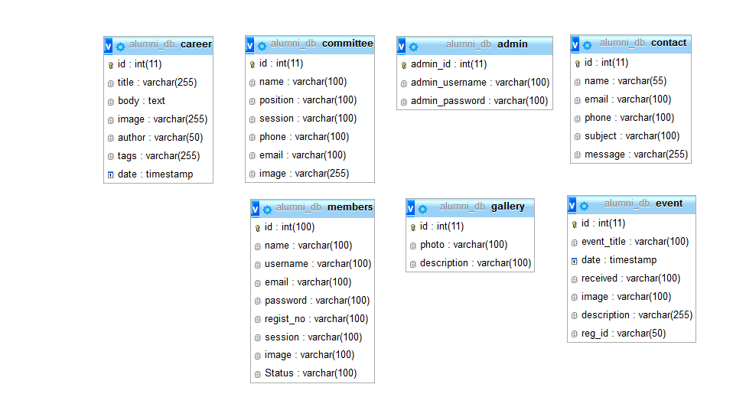

**Fig: All Database Table**

# Chapter 6 Graphical User Interface

**Overview**

In this chapter we will discuss about the User Interfaces of this websites.

**Home**

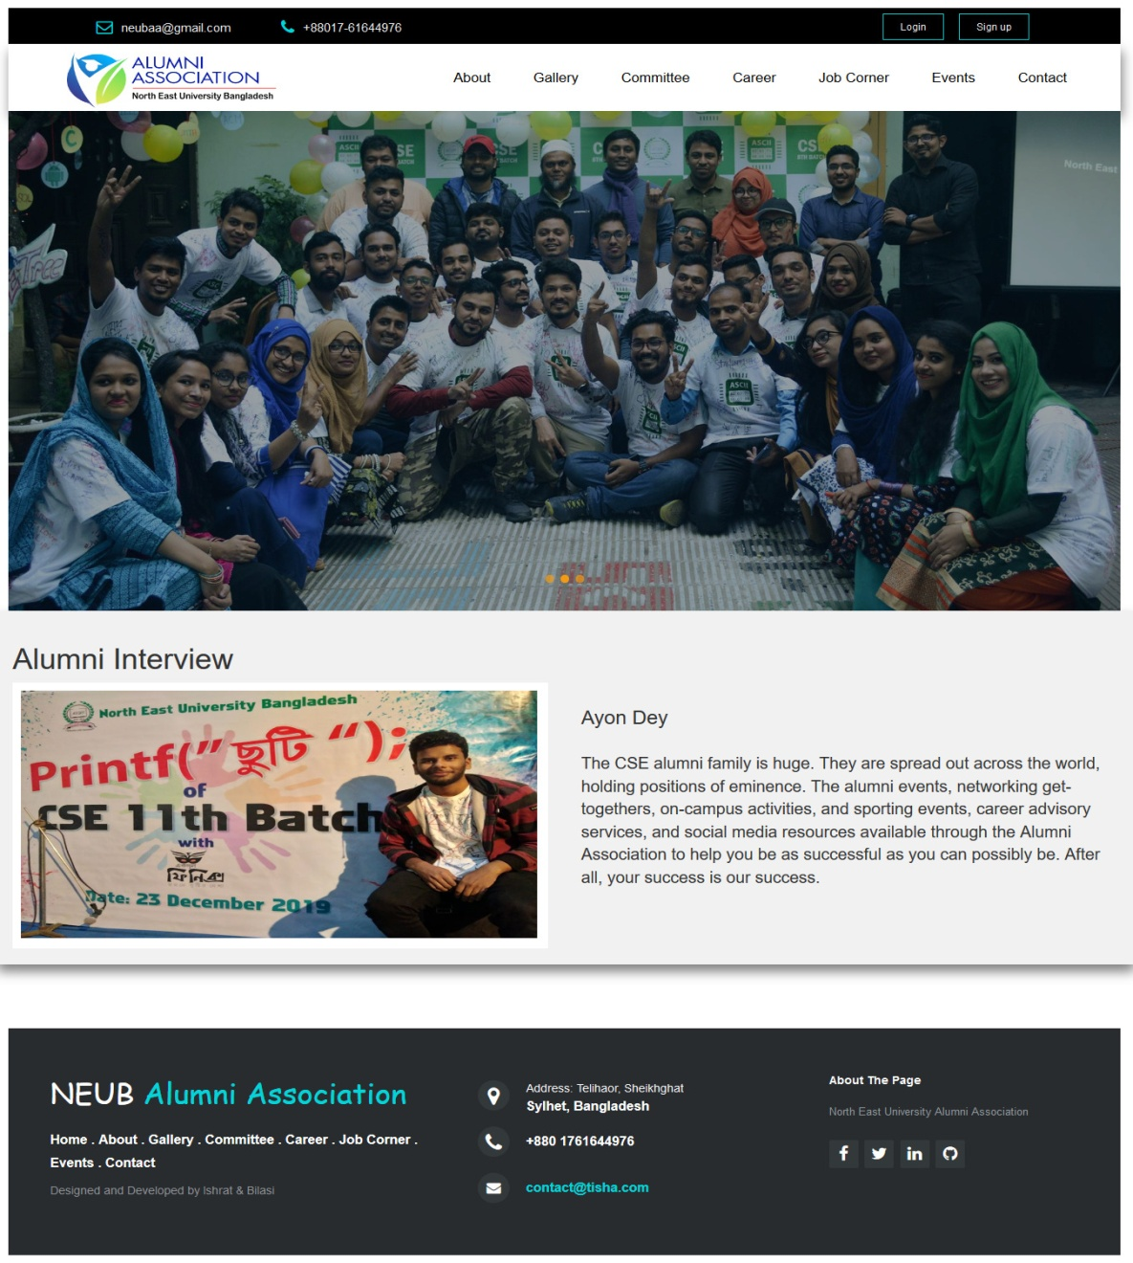

**Fig: Home Menu**

This is the home page menu bar that is the very first page where user can access all other pages to see the about, gallery, committee, career, job corner, contact us and others.

**6.2 Login (admin and users)**

**Admin login**

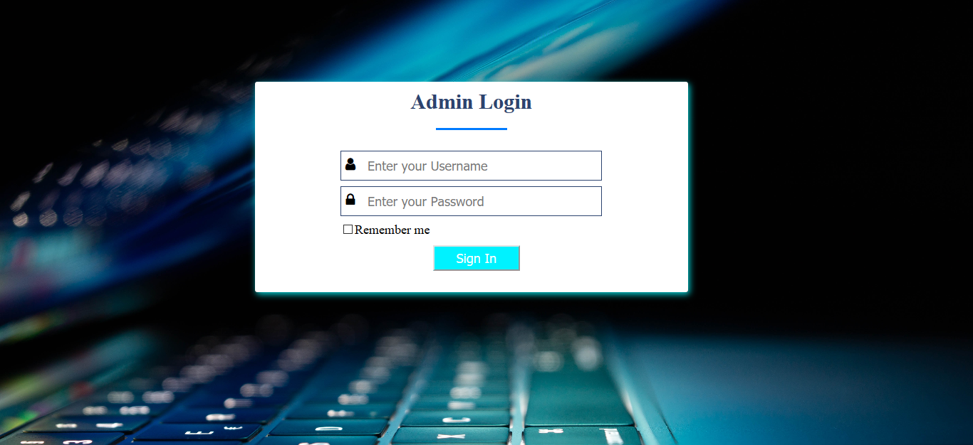

**Fig: Admin Login page**

In this page admin can login with their username and password.

**User login**

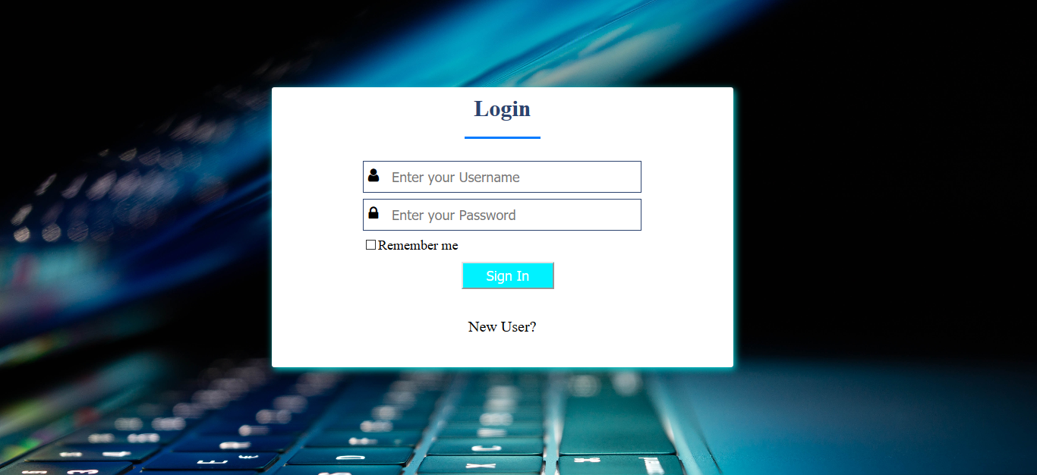

**Fig: Login page**

In this page members can login with their username and password.

**6.3 Registration form**

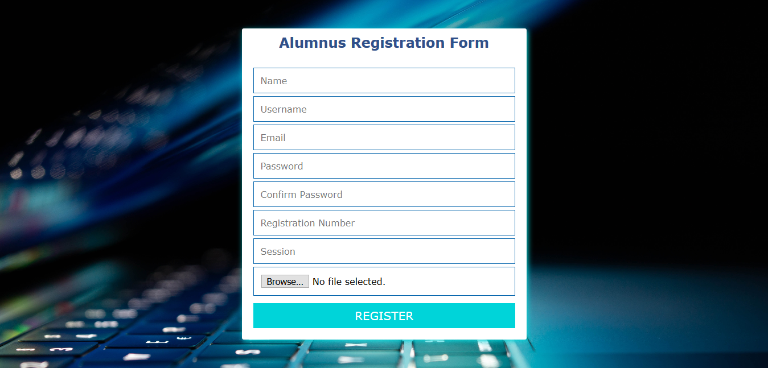

**Fig: registration form**

**6.4 About us**

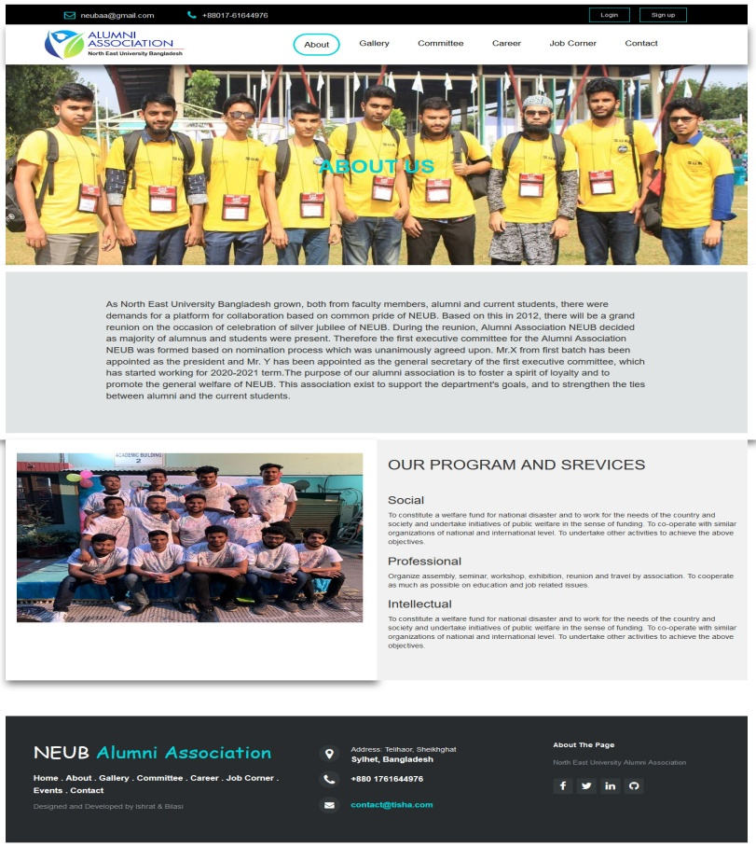

**Fig: About page**

In this page admin can organize a local or national debate with debaters.

**6.5 Gallery**

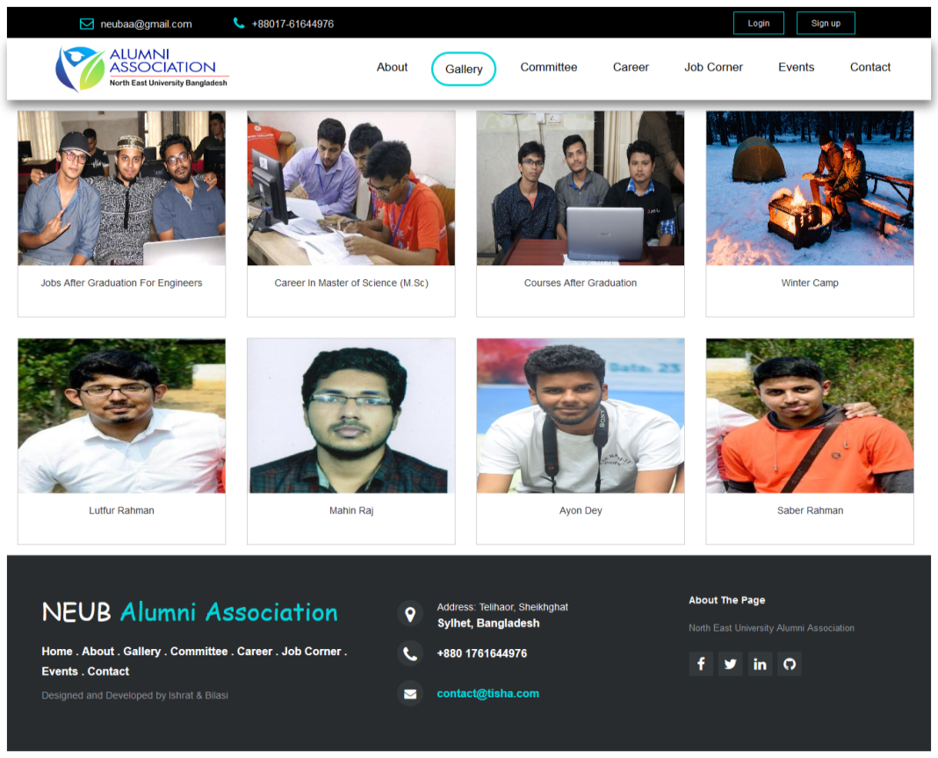

**Fig: Photo gallery**

**6.6 Committee List**

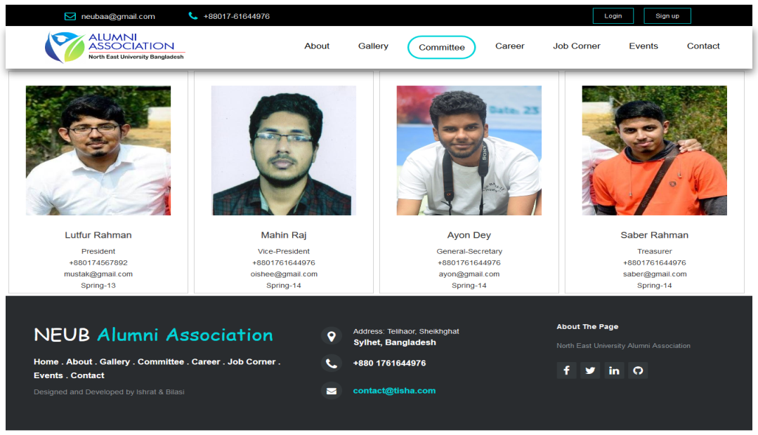

**Fig: Committee**

This page contains all committee members list.

**6.7 Event page**

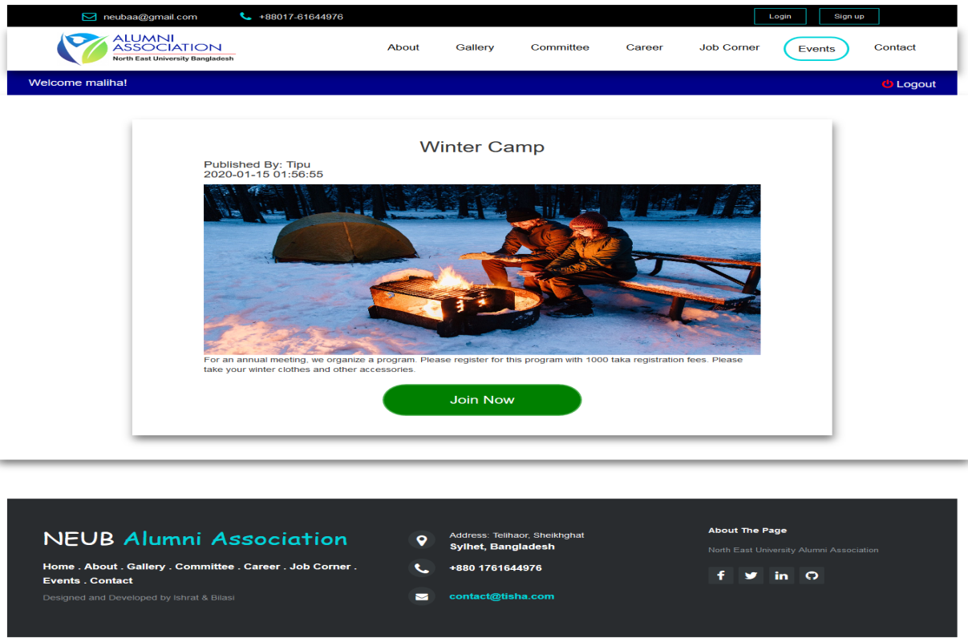

**Fig: Event and Programs**

**6.8 Contact page**

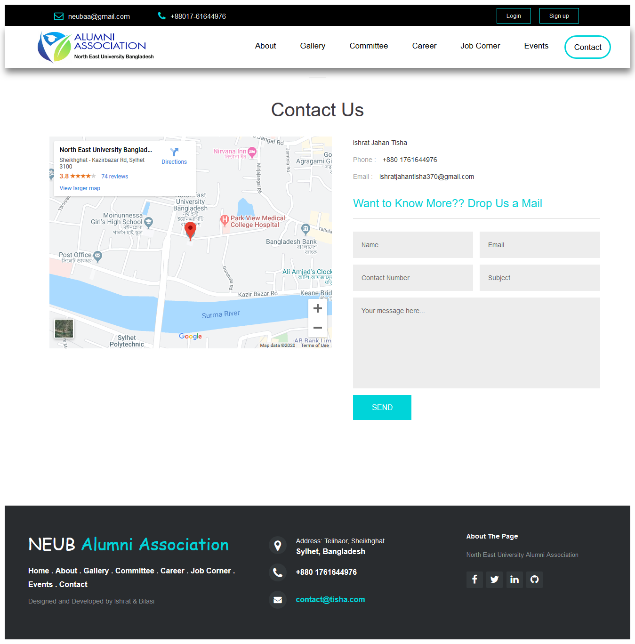

**Fig: contact page**

**6.9 Career page**

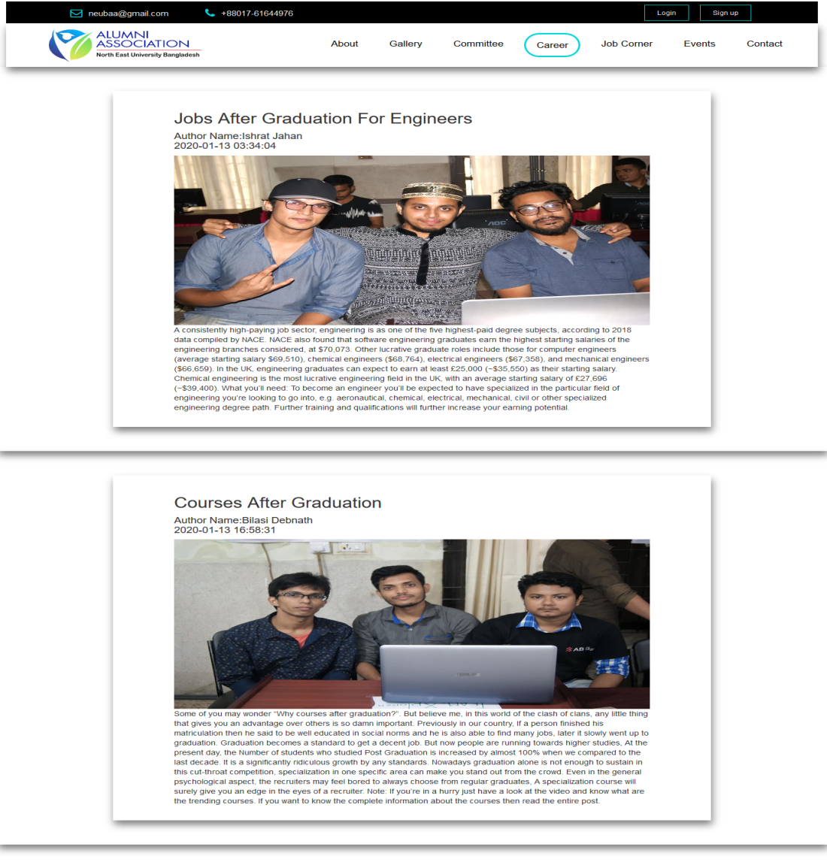

**Fig: Career page**

**6.10 Admin Dashboard page**

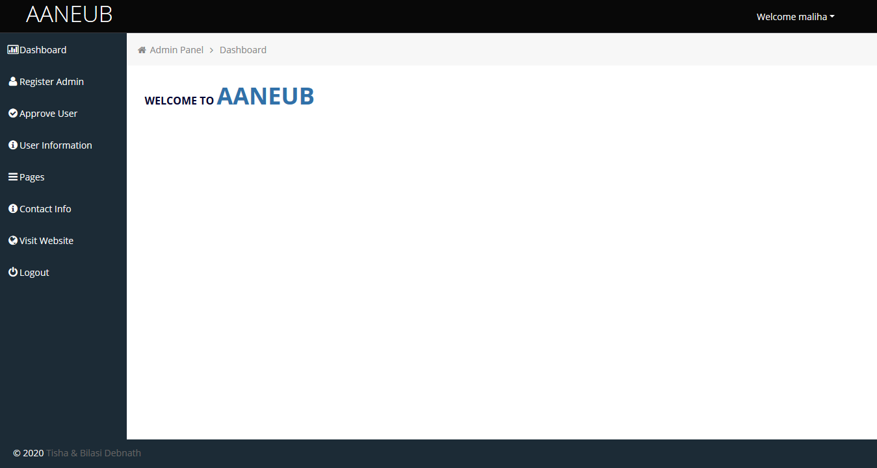

**Fig: admin dashboard page**

**6.11 Admin register page**

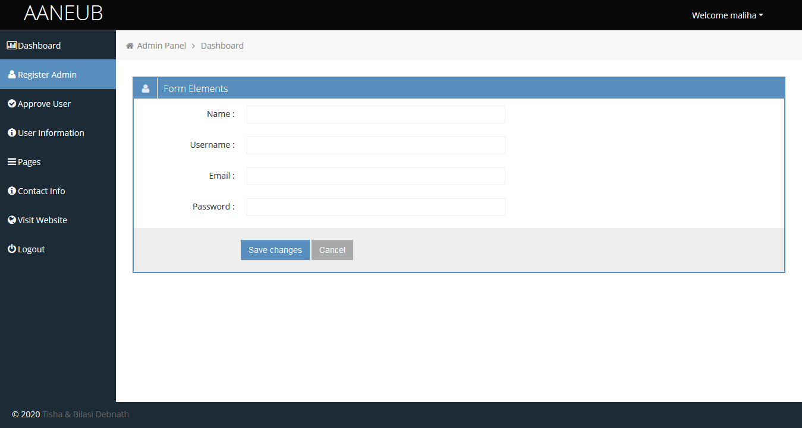

**Fig: Admin register page**

**6.12 Admin event page**

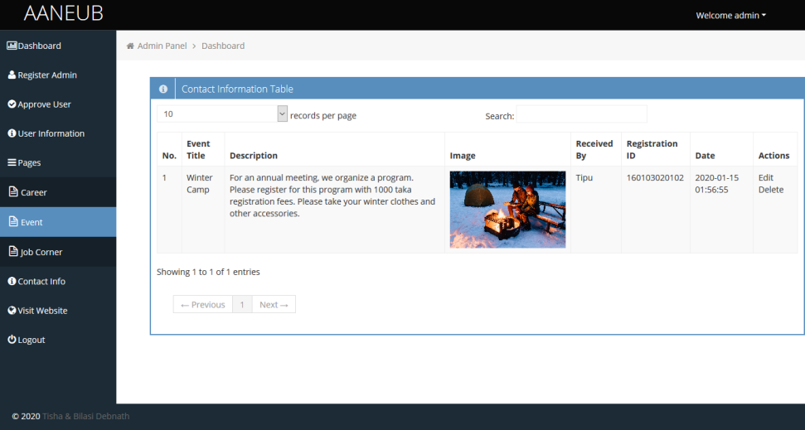

**Fig: Admin event page**

**6.13 Admin panel members list**

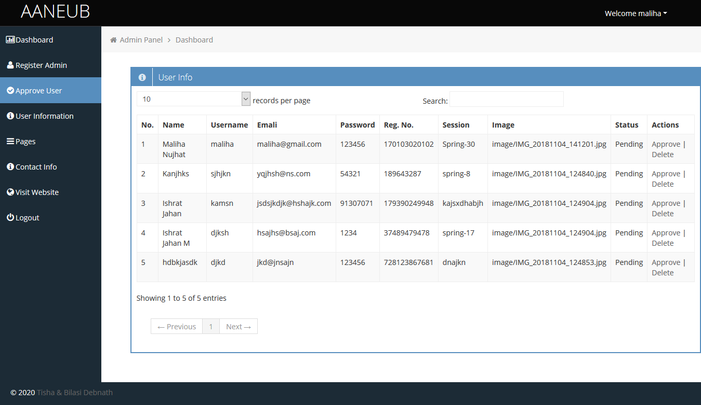

**Fig: Admin panel members list**

**6.14 Admin panel committee list**



**Fig: Admin panel committee list**

**6.15 Admin panel contact informations**

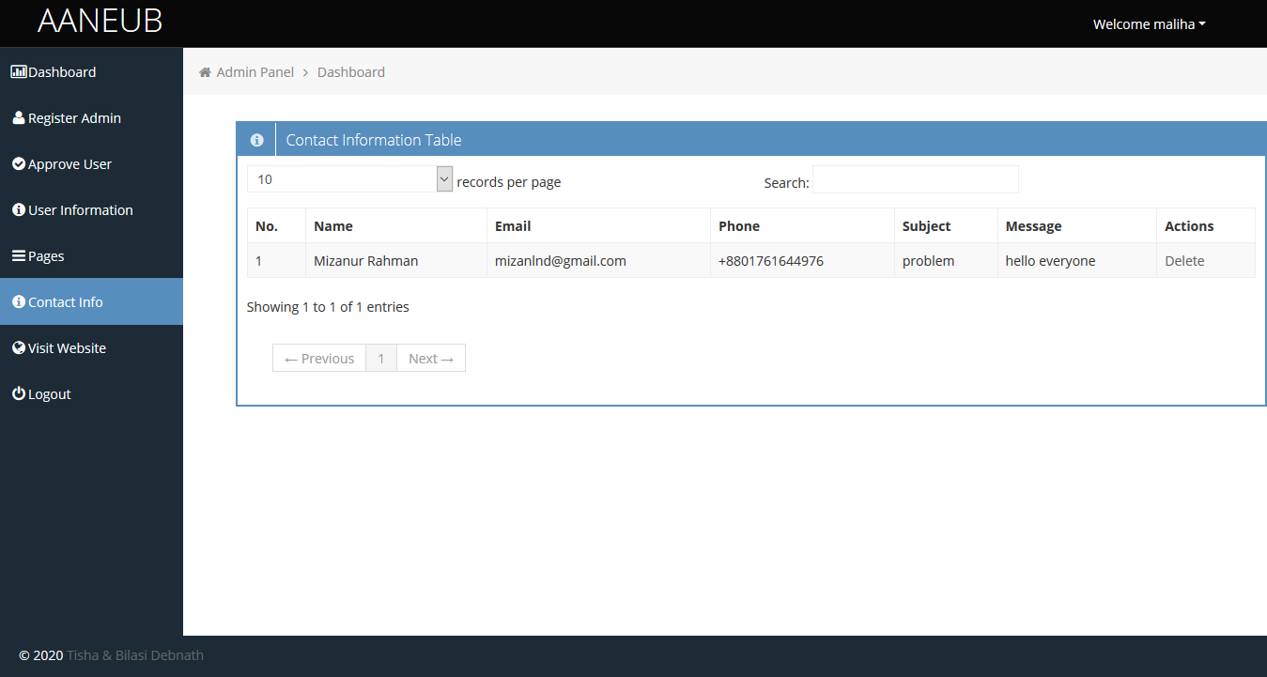

**Fig: Admin panel contact list**

**6.16 Admin panel career create post**

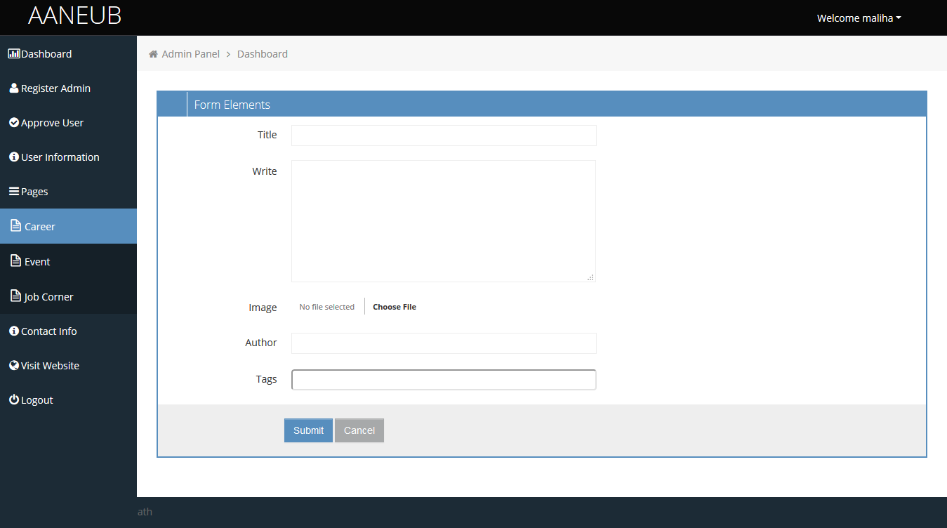

**Fig: Admin panel career create**

# TOOLS USED

* + - HTML, CSS  
      Basically HTML and CSS are mostly used for designing part that is called front end designing. Here we used html and CSS for our font end designing part. Html used for coding of design and CSS we used for make the pages attractive and user friendly.
    - W3CSS, BOOTSTRAP, JQuery, JavaScript

We used their some classes for making an efficient, attractive and responsive website, as a result our website system response very faster than before which will be user friendly for our user.

* + - PHP

We will use PHP for our back end designing part that will be implemented through coding and will make an effective relationship between students and others.

### MySQL

MySQL is an open source relational database management system([RDBMS](https://searchsqlserver.techtarget.com/definition/relational-database-management-system)) based on Structured Query Language ([SQL](https://searchsqlserver.techtarget.com/definition/SQL)). We are using MySQL. We are using MySQL for designing the database of our website.

**References**

**Books:**

1. Web Engineering: The Discipline of Systematic Development of Web Applications, Editors: Gerti Kappel, Birgit Pröll, Siegfried Reich, Werner Retschitzegger(Kappel).

2. Database System Concepts by Silberschatz, Korth and Sudarshan.

**Website:**

[https://www.neub.edu.bd/](https://www.neub.edu.bd/%20)

<https://cseaasust.org/>

[https://duaa-bd.org/](https://duaa-bd.org/%20)

[https://www.draw.io/](https://www.draw.io/%20)

**Future Work Plan:**

1. Rest of 40% backend complete within next march-2020.

2. Test Project & if any change needed will do complete within april-2020.